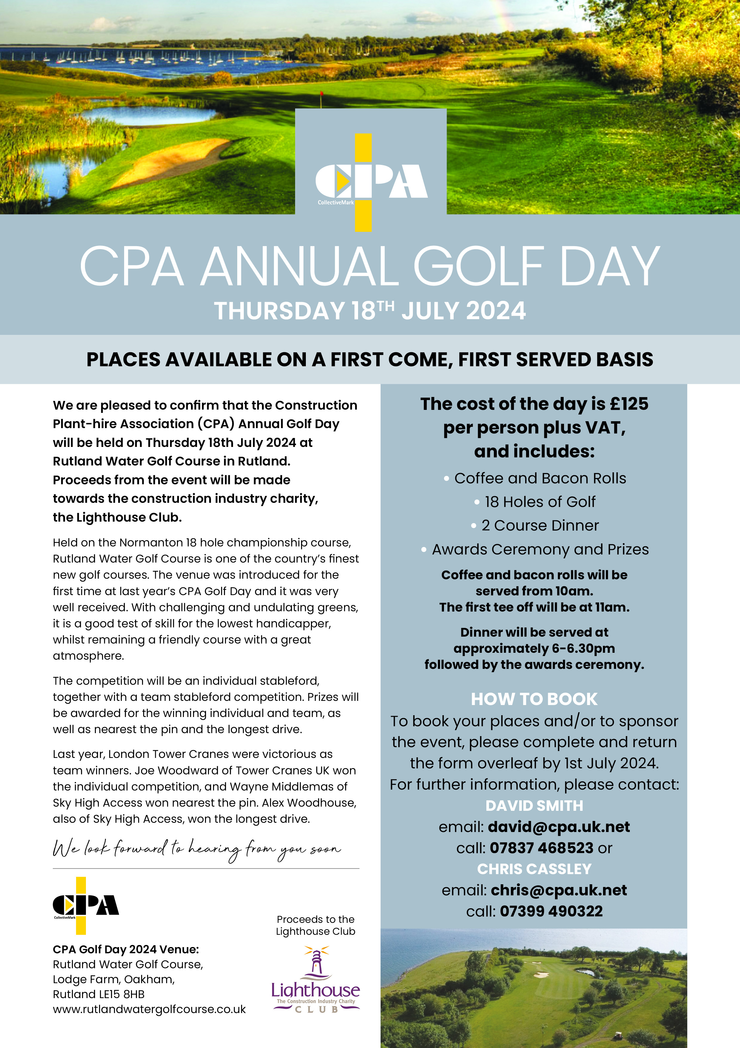

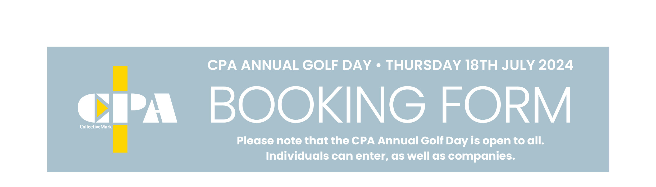

Please complete the above form and return to **David Smith** ([david@cpa.uk.net](mailto:david@cpa.uk.net)) or **Chris Cassley** ([chris@cpa.uk.net](mailto:chris@cpa.uk.net)) by **1st July 2024**. Payment should be made by BACS to:   
**Construction Plant-hire Association  
Barclays Bank •** Account No: **50294381 •** Sort Code: **20-06-72**

CPA, 27-28 Newbury Street, Barbican, London EC1A 7HU

**SPONSORSHIP**

I would like to sponsor the following (please insert an x as required):

Headline Sponsor (£500)………………… Nearest the Pin (£250)………………………….

Longest Drive (£250)……………………….. Refreshment Sponsor - Bacon Rolls/Coffee (£250)………….…

19th Hole (£250)………………………………

Company:…………………………………………………………..Contact:……………………………………….………………  
  
Telephone:………………………………………………………….Email:…………………………………………………………..

Please make your payment by BACS to the account details below, quoting reference:………………………..

**Please Note: A sponsorship pack is available outlining the packages in full. If you do not have a copy, please contact Lisa Collins on 07968 840390 or email: lisa@lisacollinscommunications.co.uk**

**Please reserve me ………… place(s) at £125 per person plus VAT**

Company/Individual:…………………………….……………………………………………………………………………………..   
  
Team Name:……………………………………………………………………………………………………………………………….

Address:…………………………………………………………………………………………………………………………………….   
  
……………………………………………………………………………….Postcode:…………………….……………………………  
  
Tel No:…………………………………………………..Email:………………………………………….………………………………

Player 1:…………………………………………………………………. Handicap:……………………………….…………………

Player 2:…………………………………………………………………. Handicap:……………………………….…………………

Player 3:…………………………………………………………………. Handicap:……………………………….…………………

Player 4:…………………………………………………………………. Handicap:……………………………….…………………